Power Query documentation
- Customers Data.xlsx
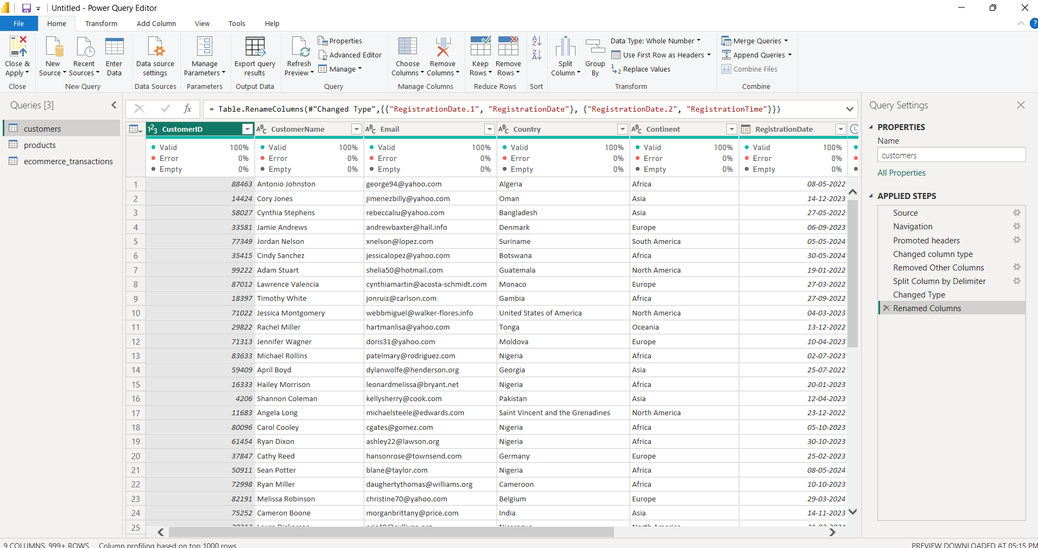
- Change RegistrationDate datatype to Date and use split column to split date and time from same column.
- Column name correction.
- Remove blank columns.
- Separate Date and time of registration from RegistrationDate column.
- Products Data.xlsx
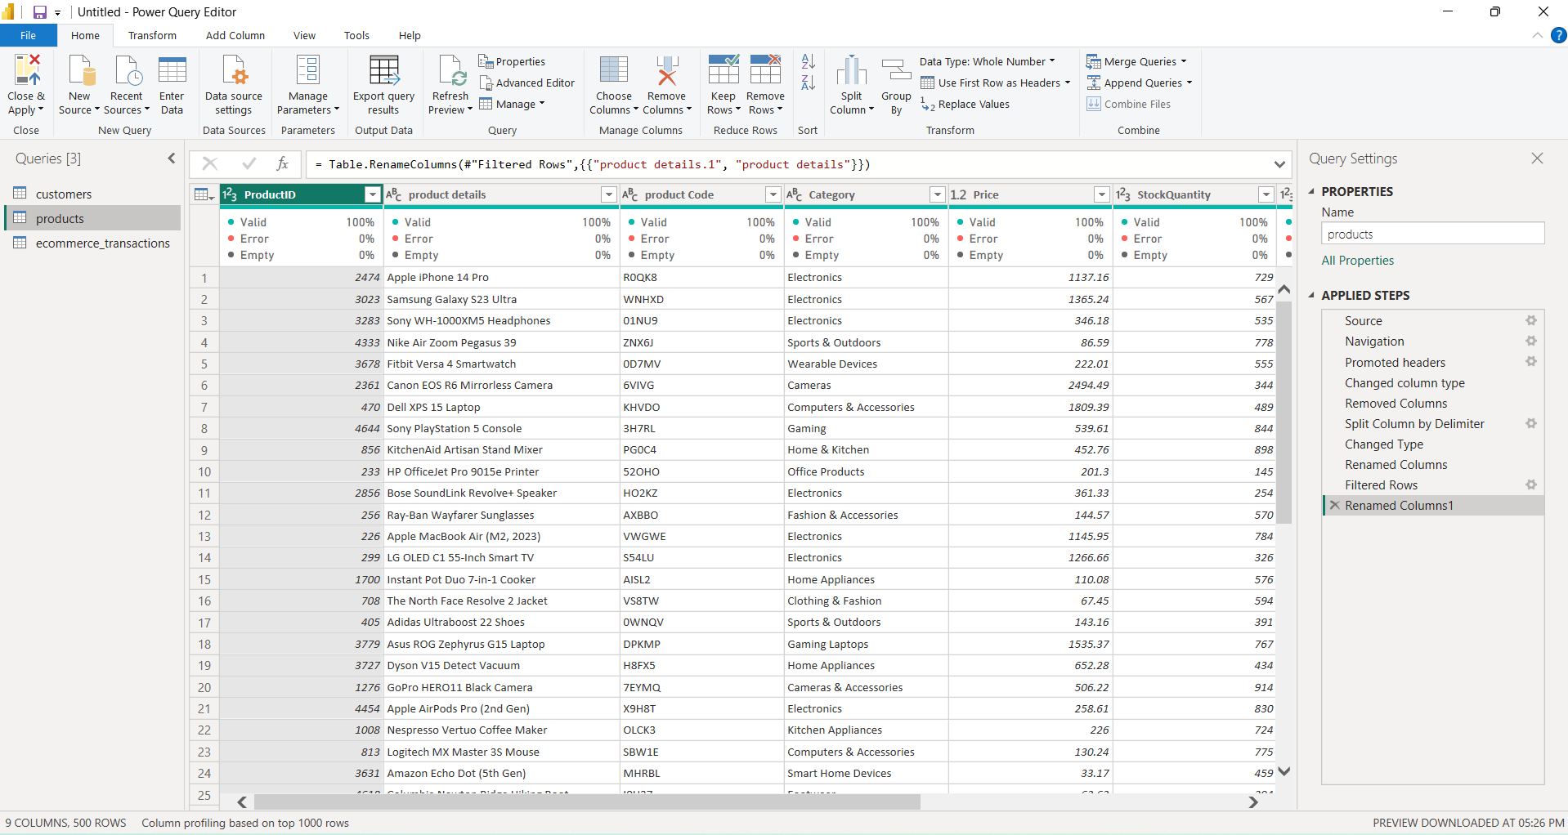
- Remove column="Subcategory" and "Product Color".
- Split product code from product details column and name correction
- Merge "Cameras" into "Cameras & Accessories"
- Merge "Kitchen Appliances" into "Home & Kitchen Appliances"
- Merge "Home & Kitchen" to "Home & Kitchen Appliances",
- Change name,"Gaming" to "Gaming Console" because it contains only PS5 console.
- Change name "Sports & Outdoors" to "Footwear" because this category has only sport shoes
- Transactions.xlsx
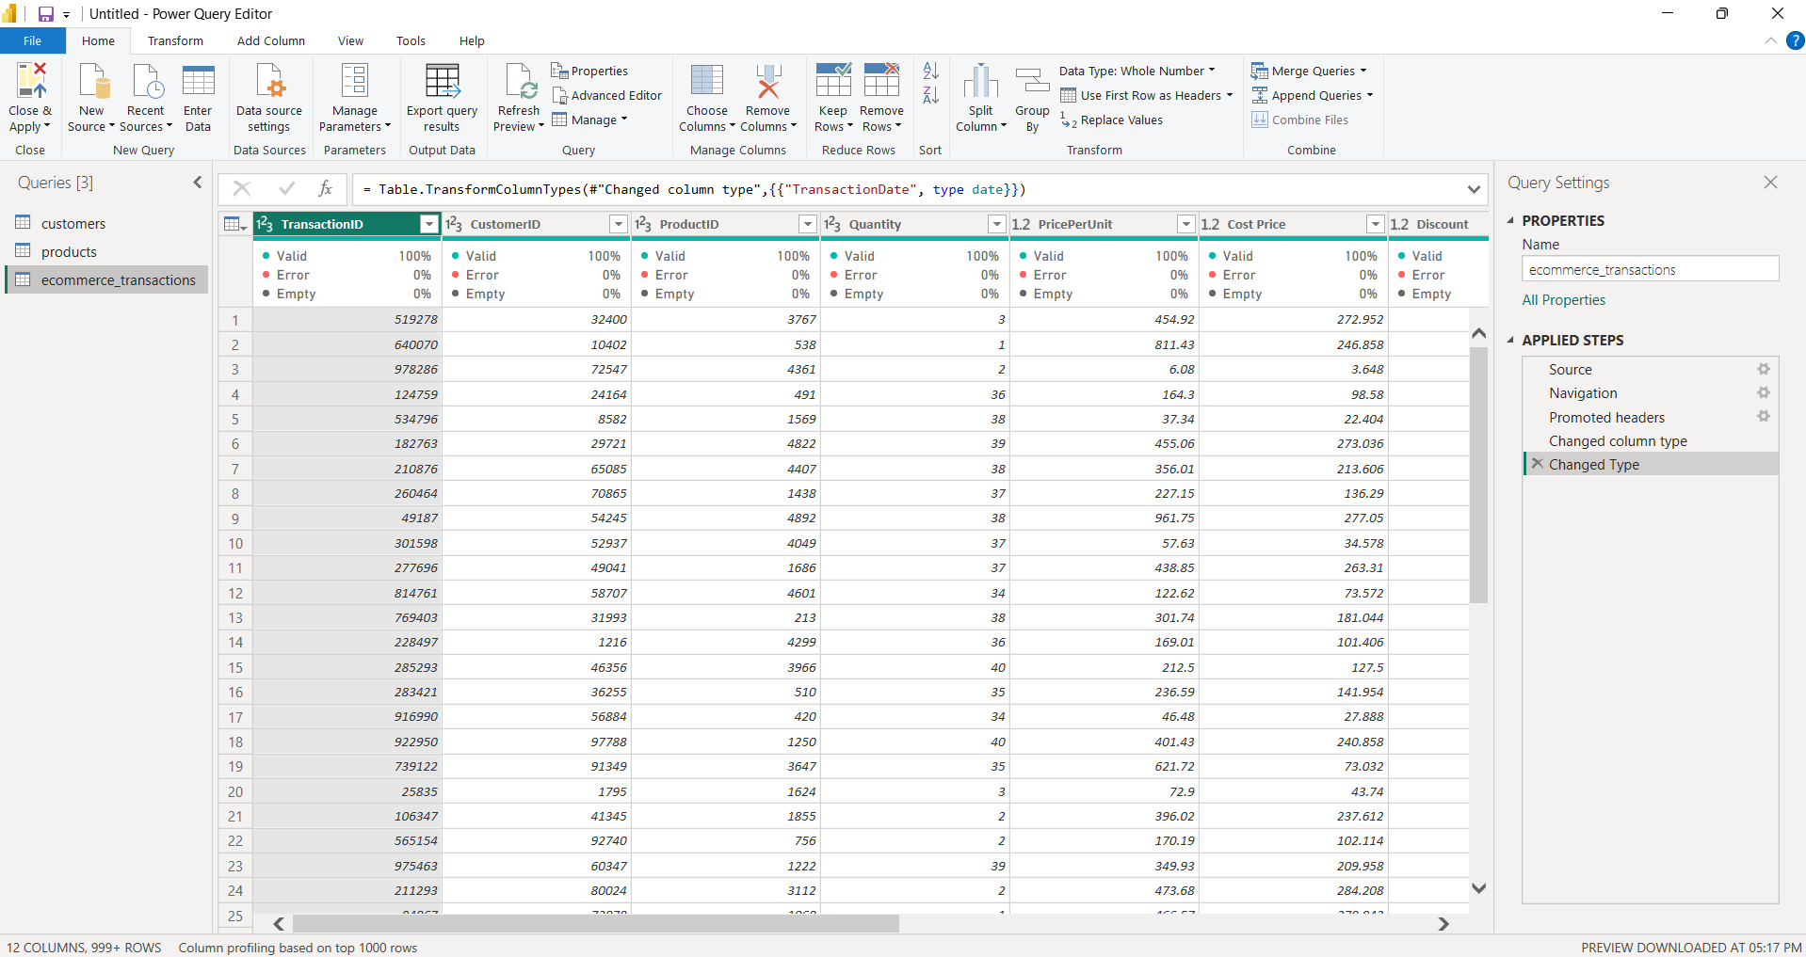
- Change TransactionDate datatype to Date.
- Remove blank columns
- Correct text in PaymentMethod column ="PayPal#" to "PayPal".
- Correct text in status column ="completed" to "Completed".
- Correct text in OrderSource column =Web" to "Website".
- Calendar Table
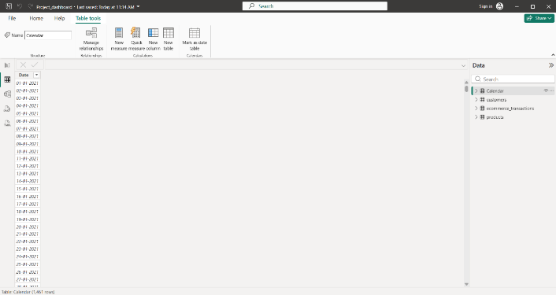
Make a calendar table.

